Nama : Aulia Eka Wulan Ardani

Nim : 071911633006

Bukti upload IG

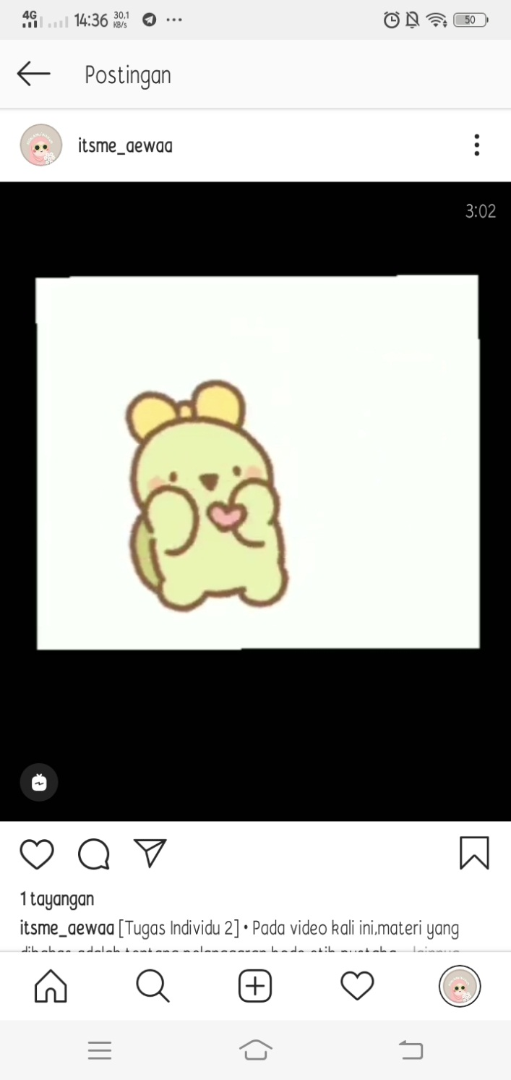

Link Video : https://www.instagram.com/tv/CFWYK1Nph3p/?igshid=l8fz0mjfkgse